1. INTRODUCTION

Telugu is an Indian language spoken by more than 50 million people in the country. Language is very rich in literature, and it requires advancements in computational approaches. Applications like machine translation, speech recognition, speech synthesis and information retrieval need a powerful morphological generator to give morphological forms of nouns and verbs .A morphological analyzer in turn needs a stemmer which is used to extract the root word.

* 1. **WHAT IS STEMMING?**

Stemming is a technique to transform different inflections and derivations of the same word to one common "stem".

Linguistically, words follow the morphological rules that allow a speaker to derive variants of a same idea to evoke an action (verb), an object or concept (noun) or the property of something (adjective). For instance, the following words are derived from the same stem "active" and share an abstract meaning of action and movement:

|  |
| --- |
| activ**ate** activ**ating** activ**e** activ**eness**  activ**ated** activ**ation** activ**ely** activ**es**  activ**ates** activ**ations** activ**eness** etc. |

Stemming deduces the stem from a fully suffixed word according to its morphological rules. These rules concern morphological and inflectional suffixes. The former type usually changes the lexical category of words, whereas the latter indicates plural and gender.

Morphological suffix: activ**ate** (verb), activ**ation** (noun). Here the "ate" and "ation" are morphological suffixes which changes the lexical category of words. By adding the suffix "ate" to the root word active ,the word became a verb. Further, on adding the suffix "ation" the root word became a noun. The stemmer which removes morphological suffixes is called as **Morphological Stemmer**.

Inflectional suffix: activation (noun), activation**s** (plural noun).In this example on removing the suffix 's' from the word activations which is a plural ,it became a singular noun. The Stemmer which removes inflections is called as **Inflectional Stemmer**.

This project "**Nativo Votos** " is a Stemmer for Telugu language. It is an inflectional stemmer.

It is based on KNS notation.

**1.2 OBJECTIVES:**

This project was developed with the following objectives:

* There are many well constructed stemmers with effective algorithms for English language like Porter's Stemmer. But there is no efficient algorithm for Telugu language because of its highly morphological nature. Even though there are few existing stemmers there are certain disadvantages in them either in the approach or in the notation used. So our aim is to develop a stemmer for Telugu language which is fully working and error free.
* Many applications like Machine learning, Search engines, Speech recognition, Information Retrieval, Morphological Analyzers require Stemmers as their basic component. Hence, our intention is to make our language computationally advanced.

**1.3 EXISTING SYSTEM:**

There are already few existing stemmers for Telugu language .Each of these stemmers follow a different algorithm and methodology .Few Stemmers are rule based and others are based on heuristics .Some of the existing stemmers are as follows:

* **Telugu morphological analyzer (TMA)** which is rule based and uses an unsupervised stemmer.
* **TELSTEM**: An unsupervised Telugu Stemmer with heuristic improvements and normalized signatures.
* **TelMore:** TelMore is a rule-based approach. It uses the results of analysis of Telugu performed by Brown's and Krishnamurti's analysis.

Any Telugu Stemmer requires input to be given in Telugu font. This input should be converted into a English representation for further processing to be done easily. All the existing stemmers use WX notation for this English reprsentation.

The WX notation is as follows:

**Vowels Representation:**

The WX notation for the thirteen vowel signs is:

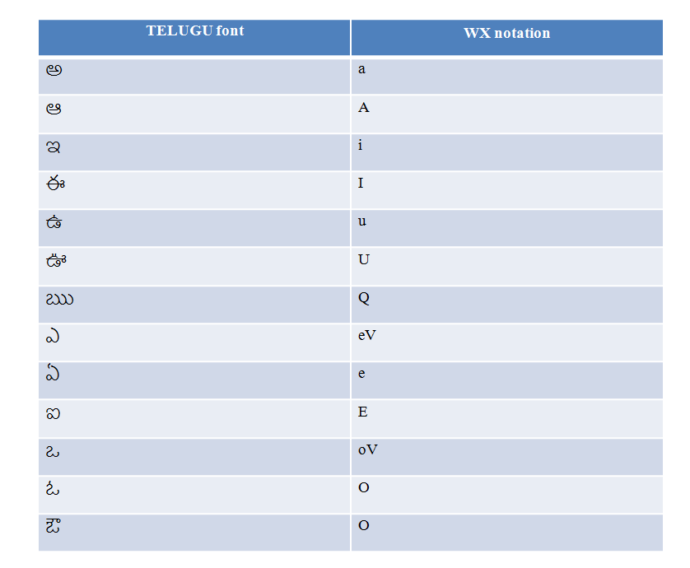

Fig:1.3.1 Vowel Representation in WX notation

**Consonants Representation:**

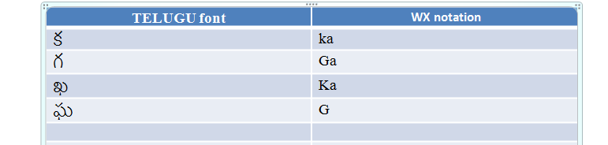

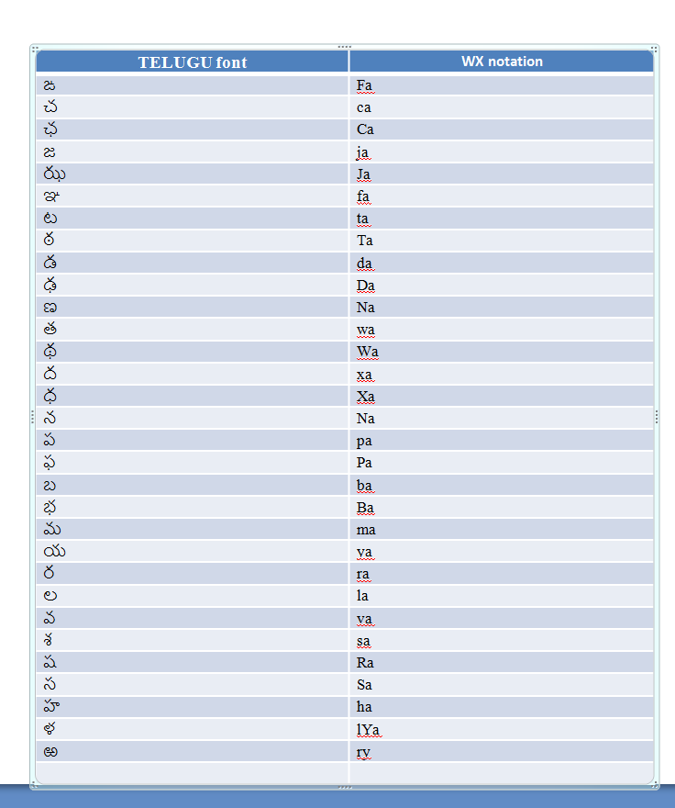

Fig:1.3.2 Consonants representation in WX notation

But there are certain disadvantages in this notation like:

1) More than one notation is used for representing the same sound i.,e all the consonant sounds are having 2 English letters which is a difficult notation to represent .

eg: The notation for the letter ఱ is ry

2) It is not an easily predictable notation i.e the sound of the English notation is different from actual telugu word sound

eg: థ-Wa, ద-xa

If you consider these two WX representations .We can find that the English notation sound is different from the Telugu sound. These disadvantages make this notation difficult for the user .

**1.4 PROPOSED SYSTEM**:

Nativo Votos is based on KNS notation. This notation removes the disadvantages of WX notation. The user does not have any complexity in understanding the notation. It is easily predictable. The notation is as follows:

**Vowels:**

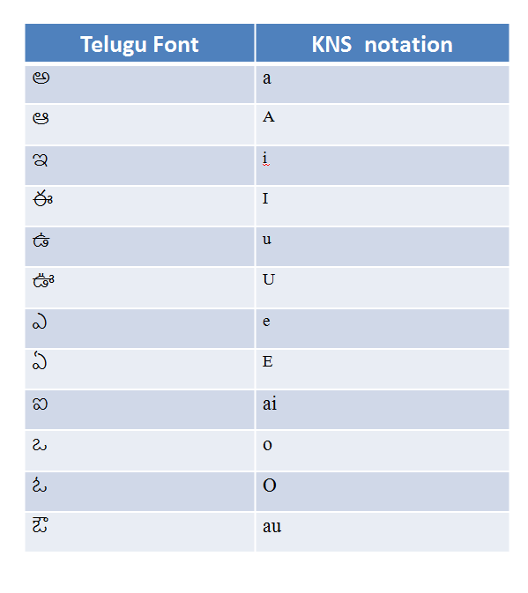Fig:1.4.1 Vowels REPRESENTATION in KNS notation

**Consonants:**

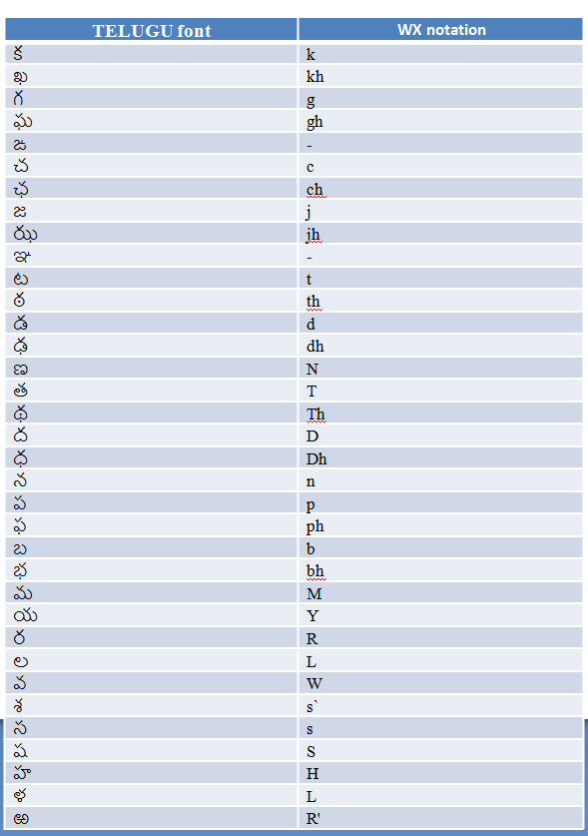

Fig:1.4.2 Consonants Representation in KNS notation

**1.4.1 Examples of KNS notation:**

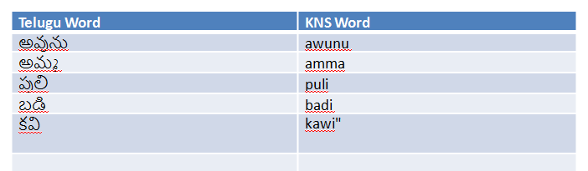

**1.5 PROCESS:**

Nativo votos is a rule based inflectional stemmer. The algorithm is based on rules of the

nature of Telugu language.

The steps in the algorithm are as follows:

1) Creation of Telugu words dictionary:

A dictionary of about 1500 Telugu words which are represented in KNS notation is developed in this project.

We have also created a stop word file where each word is represented in KNS notation

2) The user submits a Telugu word which is in KNS notation or a file of words in KNS notation.

a) If it is a file the following steps are followed:

* The stop words in the file are removed by comparing it with the stop words file.
* The unique words in the file after removing the stop words are extracted and stored in a file which is sent for further processing.
* Syllabification is done on each word in the file by applying rules and a output file which contains syllabified words is sent for the stemming process.
* Stemming is done to extract the root words for each syllabified word in the file based on inflectional rules. In this process each rule is applied on the word and if the word satisfies the rule then the corresponding root word is extracted .This extracted root word is compared with the dictionary words to check whether it is valid Telugu word or not. If it is valid we get an extracted root word as output else "invalid word" is given as output
* Finally, for each word its corresponding root word, inflection, singular/plural form is displayed on the screen.

b) If the input is a word then it is syllabified and root word is extracted by applying the rules and the output is displayed which contains the word, root word, inflection, singular/plural form

2. LITERARY SURVEY

**2.1 ALGORITHMS**

There are several types of stemming algorithms which differ in respect to performance and accuracy and how certain stemming obstacles are overcome by each of these Stemmers.

**2.1.1 Brute Force Algorithms**

These stemmers employ a lookup table which contains the relations between root forms and inflected forms. To stem a word, the table is queried to find out a matching inflection. If a matching inflection is found, the associated root form is returned. Brute force approaches are criticized for their general lack of elegance in that no algorithm is applied that would more quickly converge on a solution. In otherwords, there are more operations performed during the search than should be necessary.

Brute force searches consume immense amounts of storage to host the list of relations (relative to the task). The algorithm is only accurate to the extent that the inflected form already exists in the table. Given the number of words in a given language, like English, it is unrealistic to expect that all word forms can be captured and manually recorded by human action alone. Manual training of the algorithm is overly time intensive and the ratio between the effort and the increase in accuracy is marginal at best.

Brute force algorithms do overcome some of the challenges faced by the other approaches. Not all inflected word forms in a given language “follow the rules” appropriately. While “running” might be easy to stem to “run” in a suffix stripping approach, the alternate inflection, “ran”, is not. Suffix stripping algorithms are somewhat powerless to overcome this problem, short of increasing the number and complexity of the rules, but brute force algorithms only require storing a single extra relation between “run” and “ran”. While that is true, this assumes someone bothered to store the relation in the first place, and one of the major problems of improving brute force algorithms is the coverage of the language.

Brute force algorithms are initially very difficult to design given the immense amount of relations that must be initially stored to produce an acceptable level of accuracy (the number can span well into the millions). However, brute force algorithms are easy to improve in that decreasing the stemming error is only a matter of adding more relations to the table. Someone with only a minor experience in linguistics is capable of improving the algorithm, unlike the suffix stripping approaches which require a solid background in linguistics.

For technical accuracy, some programs may use suffix stripping to generate the lookup table given a text corpus, and then only consult the lookup table when stemming. This is not regarded as a brute force approach, although a lookup table is involved.

**2.1.2 Suffix Stripping Algorithms**

Suffix stripping algorithms do not rely on a lookup table that consists of inflected forms and root form relations. Instead, a typically smaller list of ”rules” is stored which provide a path for the algorithm, given an input word form, to find its root form.

Some examples of the rules include:

If the word ends in ‘ed’, remove the ‘ed’ if the word ends in ‘ing’, remove the ‘ing’ if the word ends in ‘ly’, remove the ‘ly’.

Suffix stripping approaches enjoy the benefit of being much simpler to maintain than brute force algorithms, assuming the maintainer is sufficiently knowledgeable in the challenges of linguistics and morphology and encoding suffix stripping rules.

Suffix stripping algorithms are sometimes regarded as crude given the poor performance when dealing with exceptional relations (like ‘ran’ and ‘run’). The solutions produced by suffix stripping algorithms are limited to those lexical categories which have well known suffixes with few exceptions. This, however, is a problem, as not all parts of speech have such a well formulated set of rules. Lemmatization attempts to improve upon this challenge.

**2.1.3 Lemmatization Algorithms:**

A more complex approach to the problem of determining a stem of a word is lemmatization. This process involves first determining the part of speech of a word, and applying different normalization rules for each part of speech. The part of speech is first detected prior to attempting to find the root since for some languages, the stemming rules change depending on a word’s part of speech.

This approach is highly conditional upon obtaining the correct lexical category (part of speech). While there is overlap between the normalization rules for certain categories, identifying the wrong category or being unable to produce the right category limits the added benefit of this approach over suffix stripping algorithms. The basic idea is that, if we are able to grasp more information about the word to be stemmed, then we are able to more accurately apply normalization rules (which are, more or less, suffix stripping rules).

**2.1.4 Stochastic Algorithms**

Stochastic algorithms involve using probability to identify the root form of a word. Stochastic algorithms are trained (they “learn”) on a table of root form to inflected form relations to develop a probabilistic model. This model is typically expressed in the form of complex linguistic rules, similar in nature to those in suffix stripping or lemmatization. Stemming is performed by inputting an inflected form to the trained model and having the model produce the root form according to its internal rule set, which again is similar to suffix stripping and lemmatization, except that the decisions involved in applying the most appropriate rule, or whether or not to stem the word and just return the same word, or whether to apply two different rules sequentially, are applied on the grounds that the output word will have the highest probability of being correct (which is to say, the smallest probability of being incorrect, which is how it is typically measured).

Some lemmatization algorithms are stochastic in that, given a word which may belong to multiple parts of speech, a probability is assigned to each possible part. This may take into account the surrounding words, called the context, or not. Context-free grammars do not take into account any additional information. In either case, after assigning the probabilities to each possible part of speech, the most likely part of speech is chosen, and from there the appropriate normalization rules are applied to the input word to produce the normalized (root) form.

**2.1.5 Hybrid Approaches**

Hybrid approaches use two or more of the approaches described above in unison. A simple example is a suffix tree algorithm which first consults a lookup table using brute force. However, instead of trying to store the entire set of relations between words in a given language, the lookup table is kept small and is only used to store a minute amount of “frequent exceptions” like “ran => run”. If the word is not in the exception list, apply suffix stripping or lemmatization and output the result.

**2.1.6Affix Stemmers**

In linguistic, the term affix refers to either a prefix or suffix. In addition to dealing with suffixes, several approaches also attempt to remove common prefixes. For example, given the word indefinitely, identify that the leading “in” is a prefix that can be removed. Many of the same approaches mentioned earlier apply, but go by the name affix stripping.

**2.1.7 Matching Algorithms**

These algorithms use a stem database (for example a set of documents that contain stem words). These stems, as mentioned above, are not necessarily valid words themselves (but rather common sub-strings, as the “brows” in “browse” and in “browsing”). In order to stem a word the algorithm tries to match it with stems from the database, applying various constraints, such as on the relative length of the candidate stem within the word (so that, for example, the short prefix “be”, which is the stem of such words as “be”, “been” and “being”, would not be considered as the stem of the word “beside”).

**2.1.8 Language Challenges**

While much of the early academic work in this area was focused on the English language (with significant use of the Porter Stemmer algorithm), many other languages have been investigated.

Hebrew and Arabic are still considered difficult research languages for stemming. English stemmers are fairly trivial (with only occasional problems, such as “dries” being the third-person singular present form of the verb “dry”, “axes” being the plural of “axe” as well as “axis”); but stemmers become harder to design as the morphology, orthography, and character encoding of the target language becomes more complex. For example, an Italian stemmer is more complex than an English one (because of more possible verb inflections), a Russian one is more complex (more possible noun declensions), a Hebrew one is even more complex (due to non-catenative morphology and a writing system without vowels), and so on, while a stemmer for Hungarian would be easier to implement due to the precise rules in the language for flexion

**2.1.9 Multilingual Stemming**

Multilingual stemming applies morphological rules of two or more languages simultaneously instead of rules for only a single language when interpreting a search query. Commercial systems using multilingual stemming exist.

**2.2 COMPARISON OF STEMMING AND LEMMATIZATION :**

The motivation for using stemming instead of lemmatization, or indeed tagging of the text, are mainly a question of cost. It is considerably more expensive, in terms of time and effort, to develop a well performing lemmatizer than to develop a well performing stemmer. It is also more expensive in terms of computational power and run time to use a lemmatizer than to use a stemmer. The reason for this is that the stemmer can use ad-hoc suffix and prefix stripping rules and exception lists while the lemmatizer must do a complete morphological analysis (based on an actual grammatical rules and a dictionary). Another point of motivation is that a stemmer can deliberately “bring together” semantically related words belonging to different word classes to the same stem, which a lemmatizer cannot.

The goal of both stemming and lemmatization is to reduce inflectional forms and sometimes derivationally related forms of a word to a common base form. The two words stemming and lemmatization differs in their flavor. Stemming usually refers to a crudeh euristic process that chops off the ends of words in the hope of achieving this goal correctly most of the time, and often includes the removal of derivational affixes.

Lemmatization usually refers to doing things properly with the use of a vocabulary and morphological analysis of words, normally aiming to remove inflectional endings only and to return the base or dictionary form of a word, which is known as the lemma. If confronted with the token “saw”, stemming might return just s, whereas lemmatization would attempt to return either see or saw depending on whether the use of the token was as a verb or a noun. The two may also differ in that stemming most commonly collapses derivationally related words, whereas lemmatization commonly collapses only the different inflectional forms of a lemma. Linguistic processing for stemming or lemmatization is often done by an additional plug-in component to the indexing process and a number of such components exist in both commercial and open-source.

Stemmers use language-specific rules, but they require less knowledge than a lemmatizer, which needs a complete vocabulary and morphological analysis to correctly lemmatize words. Particular domains may also require special stemming rules. However, the exact stemmed form does not matter, only the equivalence classes it forms. Rather than using a stemmer, you can use a lemmatizer , a tool from Natural Language Processing which does full morphological analysis to accurately identify the lemma for each word. Doing the full morphological analysis produces at most very modest benefits for retrieval. It is hard to say more, because either form of normalization tends not to improve English information retrievalperformance in aggregate - at least not by very much. While it helps a lot for some queries, it equally hurts performance a lot of others. Stemming increases recall while harming precision.

As an example of what can go wrong, note that the Porter stemmer stems all of the following words: operate, operating, operates, operation, operative, operatives, operational to “oper”. However, since “operate” is a common verb in this various forms, we would expect to lose considerable precision on queries such as the following with

**2.2.1 Porter stemming:**

Operational and research operating and system operative and dentistry. For a case like this, moving to using a lemmatizer would not completely fix the problem. Because, particular inflectional forms are used in particular collocations: for a sentence with any of the various forms of the word “operate”, the system is not a good match for the query “operating and system”. Getting better value from term normalization depends more on pragmatic issues of word use than on formal issues of linguistic morphology. Affix removal algorithms remove suffixes and/or prefixes from terms leaving a stem.

**2.3 ERRORS IN STEMMING:**

Natural languages are not completely regular constructs and therefore stemmers operating on natural words inevitably make mistakes. On the one hand, words which ought to be merged together (such as "adhere" and "adhesion") may remain distinct after stemming; on the other, words which are really distinct may be wrongly conflated (e.g., "experiment" and "experience"). These are known as understemming errors and overstemming errors respectively. By counting these errors for a sample of words, we can gain an insight into the operation of a stemmer, and compare different stemmers.

To enable the errors to be counted, the words in the collection must already be organized into 'conceptual groups', containing words (such as "adhere", "adheres", "adhering", "adhesion", "adhesive") which ought all to be merged to the same stem.

* If the two words belong to the same conceptual group, and are converted to the same stem, then the conflation is correct; if however they are converted to different stems, this is counted as an understemming error.
* If the two words belong to different conceptual groups, and remain distinct after stemming, then the stemmer has behaved correctly. If however they are converted to the same stem, this is counted as an overstemming error.

.

**2.4 BENEFITS OF STEMMING:**

Stemming takes care of morphological variants. When an index is stemmed, users do not need to include several forms of a same word in a query: "sale OR sales". Stemming handles these variations such that the queries "sale" and "sales" will return the same results. It reduces index size. Indexed terms are stored in the lexicon.

A stemmed index means that the linguistic roots are stored in the lexicon rather than in the whole terms. Each entry in the lexicon contains references to documents in which it appears. When stemming is used, several terms are conflated as well as information relative to document references, hence significantly reducing the size of the index

**2.5 LIMITATIONS OF STEMMING:**

It is important to keep in mind that the stemming limitations tend to disappear with queries including more than one term. Since more documents are likely to be retrieved by a single query, the desired documents may be returned with a large number of other related documents. If a query returns too many documents, narrow it down by adding more words to the query.

Exceptions to stemming rules. Although stemming has been used since the early days of computer science, algorithms that were developed for that purpose still suffer from the same limitation, that is, the conflation of words that are not semantically related, such as "university" and "universal". This means that a query containing the term "universal" may retrieve a document that contains "university". Although stemming rules' exceptions are limited, it would be expensive to handle them in terms of memory and speed, given their relative rareness.

It is then required to understand the stemming mechanisms to recognize and bypass these situations when they happen, because Coveo Enterprise Search's "Optimized for English" and "Multilingual Stemming" both suffer from this limitation. Impact on advanced syntax and exact match. Advanced syntax and exact match queries work the same, but the terms in such queries are stemmed. In the case of advanced syntax, it can lead to unexpected results, if different terms in the query share the same stem. For instance, "consumers NOT consuming" is stemmed to "consum- NOT consum-" and leads to no result. Exact match queries can also occasionally retrieve non expected results because Coveo Enterprise Search looks for exact matches of stems.

For instance, the exact match string "sales reports" matches "sal- report-". Accented characters are not supported. For performance purposes only, Coveo Enterprise Search removes accents from characters before stemming. Consequently, some accented characters in stems lose their distinction in languages such as French, Spanish and German, although, this very rarely leads to confusion between stems. The short words are not stemmed. Words of four or fewer letters are not stemmed. Short words tend to be more error prone to stemming; especially in English, where concerns must be addressed to recognize short and long syllables. Since this situation refers to only a small number of terms, the short words are not stemmed to favor performance.

Therefore, morphological variations of short words will not be implicitly included in a query.

**2.6 APPLICATIONS:**

**Information Retrieval**

Stemmers are common elements in IR systems, since a user who runs a query on “daffodils” would probably also be interested in documents that contain the word “daffodil” (without the s). The effectiveness of stemming for English query systems was soon found to be rather limited, however, and this has led early information retrieval researchers to deem stemming irrelevant in general. An alternative approach, based on searching for n -grams rather than stems, may be used instead. Also, recent research has shown greater benefits for retrieval in other languages.

**Commercial Uses:**

Many commercial companies have been using stemming since at least the 1980’s and have produced algorithmic and lexical stemmers in many languages. The Snowball stemmers have been compared with commercial lexical stemmers with varying results.

Google adopted word stemming in 2003. For example initially a search for “fish” would not have returned “fishing”. Other software search algorithms vary in their use of word stemming. Programs that simply search for substrings obviously will find “fish” in “fishing” but when searching for “fishes” will not find occurrences of the word “fish”.

3. MODULES

The back end process has 3 modules. They are as follows:

* Syllabification
* Stemmer
* File Upload

The detailed description of each step is described below:

**3.1 SYLLABIFICATION:**

Syllabification is the separation of a word into syllables whether spoken or written.The written separation is usually marked by a hyphen when using English orthography (e.g., syl-la-ble) and with a period when transcribing in the International Phonetic Alphabet (IPA) (e.g., [ˈsɪl.ə.bᵊɫ]). For presentation purposes, typographers may use an interpunct (Unicode character U+00B7, e.g., syl·la·ble), or a special-purpose "hyphenation point" (U+2027, e.g., syl‧la‧ble). Occasionally, a space (or the word divider of the particular language) is used (e.g., syl la ble).

At the end of a line, a word is separated in writing into parts conventionally called "syllables" if it does not fit and if moving it to the next line would make the first line much shorter than the others. This can be a particular problem with very long words. Word processing has automated the process of justification, making syllabification of shorter words often superfluous.

In some languages, the spoken syllables are also the basis of syllabification in writing. However, possibly due to the weak correspondence between sounds and letters in the spelling of modern English, written syllabification in English is based mostly on etymological or morphological instead of phonetic principles. For example, it is not possible to syllabify "learning" as lear-ning according to the correct syllabification of the living language. Seeing only lear- at the end of a line might mislead the reader into pronouncing the word incorrectly, as the digraph ea can hold many different values. The history of English orthography accounts for such phenomena. English written syllabification therefore deals with a concept of "syllable" that doesn't correspond to the linguistic concept of a phonological (as opposed to morphological) unit.

As a result, even most native English speakers are unable to syllabify words accurately without consulting a dictionary or using a word processor[citation needed]. The process is, in fact, so complicated that even schools usually do not provide much more advice on the topic than to consult a dictionary. In addition, there are differences between British and US syllabification and even between dictionaries of the same English variety.

In Finnish, Italian, Portuguese and other nearly phonemically spelled languages, writers can in principle correctly syllabify any existing or newly created word using only general rules. In Finland, children are first taught to hyphenate every word until they produce the correct syllabification reliably, after which the hyphens can be omitted. Every consonant is represented as ‘c’ and every vowel with ‘v’.

Eg: nAnnagAriki

n-A-n-n-a-g-A-r-i-k-i

c-v-c-c-v-c-v-c-v-c-v

These lexemes are stored in an array and the array is processed to tag s the type of lexeme by applying the rules of syllabification one by one.

**Applying Rule 1:**

“No two vowels come together in Telugu literature.”The given user input does not have two vowels together. Hence this rule is satisfied by the given user input. The output after applying this rule is same as above. If the rule is not satisfied, an error message is displayed that the given input is incorrect. Now the array is:

c-v-c-c-v-c-v-c-v-c-v

**Applying Rule 2:**

“Initial and final consonants in a word go with the first and last vowel respectively.”

Telugu literature rarely has the words which end up with a consonant. Almost all the Telugu words end with a vowel. The application of this rule2 from left to right, changes the array as following:

c-v-c-c-v-c-v-c-v-c-v

cv-c-c-v-c-v-c-v-cv

The generated output is further processed by applying the other rules.

**Applying Rule 3:**

“VCV: The C goes with the right vowel.”

The string wherever has the form of VCV, then this rule is applied by dividing it as V-CV. In the above rule the consonant is combined with the vowel, but here in this rule the consonant is combined with the right vowel and separated from the left vowel. To the output generated by the application of rule2, this rule is applied and the output will be as:

cv-c-c-v-c-v-c-v-cv

cv-c-c-v-cv-cv-cv

This output is not yet completely syllable, one more rule is to be applied which finishes the syllabification of the given user input word.

**Applying Rule 4:**

“Two or more Cs between Vs – First C goes to the left and the rest to right.”

It is the string which is in the form of VCCC*V, then according to this rule it is split as VC-CC*V. In the above output VCCV in the string can be syllabified as VC-CV. Then the output becomes:

cv-c-c-v-cv-cv-cv

cvc-cv-cv-cv-cv

Now this output is converted to the respective consonants and vowels.

Thus saving the complete syllabified form of the given user input.

n-A-n-n-a-g-A-r-i-k-i

nA-n-n-a-g-A-r-i-ki

nA-n-n-a-g-A-ri-ki

nAn-na-gA-ri-ki

Hence, for the given user input, “nAnnagAriki”, the generated syllabified form is “nAn-na-gA-ri-ki”.

**Applying Rule 5:**

“When a word ends with a consonant, it gets attached to the previous syllable.”If there is a string which is in the form of VCV*CVC, then according to this rule, it is split as V-CV*-CVC.

a-m-e-r-i-k-a-n

v-c-v-c-v-c-v-c

v-cv-cv-cvc

a-me-ri-kan

**3.2 STEMMING**:

Stemming requires extracting root word .It is of 2 forms:

1)The word can be an inflected plural this requires converting the inflected plural into a normal plural by following 4 rules and then converting the plural into singular plural by following 13 rules.

eg: nAyakurALLaki is a inflected plural form .The inflection is ki and La is the plural indication. So we need to remove the inflection ki and convert it into a plural form which is nAyakurALLu. This is further converted into singular form nAyakurAlu by following certain rules .

2)The word can be an inflected singular which just requires removing the inflection.

eg: paniki is an inflected word where ki is the inflection.In Stemming the inflection ki is removed and the root word pani is extracted.

The process is as follows

User input word

Inflected Singular word

Inflected Plural Word

Inflection

Singular Word

Inflection

Plural Word

Singular Word

Fig: 3.2.1 Stemming

**3.2.1 HANDLING INFLECTED PLURALS**

Modification of a word to express various tenses,voices, moods, numbers, genders, persons, etc. is known as inflection (‘*vibhakti*’) . Declension isthe inflection of nouns, pronouns and adjectives. Conjugation is the inflection of verbs. Inflectionstake place at the rear end of words. Since every word is an inflection of a root verb (‘*dhAtu*’) in Sanskrit, conjugations are possible in Sanskrit but not in Telugu . As per the grammar, there are eight inflections in Telugu as described in the below table. Eighth inflection is less significant.

|  |  |  |
| --- | --- | --- |
| **Vibhkti** | **Type** | **Types of Declarations** |
| prathamA | Nominative | Du mu vu lu |
| DvitIyA | Accusative | Ni nu lanu kUrci guriMci |
| TRtIyA | Instrumental | cEta cE tODa tO |
| Caturthi | Dative | Koraku kY |
| paMcamI | Ablative | Valana kaMTe paTTi |
| ShashTi | Possessive | Ki ku yokka lO lOpala |
| saptamI | Locative | aMdu na |
| saMbOdhana prathamA | Vocative | Ori Osi Oyi hE etc are prefixed to the Nominatives. |

Fig: 3.2.1.1 Vibhakti table

Solutions to obtain the plurals from inflected plurals.:

The following are the rules to obtain plural forms:

|  |  |
| --- | --- |
| **Observation** | **Methods** |
| La+inflection | 1.Replace observation with ‘lu’ |
| LLa+inflection | 2.Replace observation with ‘LLu’ |
| Ra+ inflection | 3. Replace observation with ‘ru’ |
| I+inflection(colloquial) | 4. Replace observation with ‘lu’ |

Fig: 3.2.1.2 Plural Rules

Obtaining Singular from plural Nominatives:

There are 13 rules for this process:

**Rule1:**

If the plural ends with "Alu" then it is converted into "amu". The following are the examples for this rule:

|  |  |
| --- | --- |
| dAnAlu | dAnamu |
| simhAlu | Simhamu |
| dinAlu | Dinamu |
| iBAlu | iBamu |

eg:Consider the word **dAnAlu**

The output of this word is **dAnamu**

**Rule2:**

If the plural ends with "ulu" then it is converted into "i". The following are the examples for this rule:

|  |  |
| --- | --- |
| kAkulu | kAki |
| kaMkulu | kaMki |
| bOkulu | bOki |
| elakulu | Elaki |

eg:Consider the word **panulaki**

The output of this word is **pani**

**Rule3:**

If the plural ends with "Tlu" then it is converted into "Tu". The following are the examples for this rule:

|  |  |
| --- | --- |
| baMTlu | baMTu |
| kATlu | kATu |
| pATlu | pATu |
| alavATlu | alavATu |

eg:Consider the word **bamDlu**

The output of this word is **bamTu**

**Rule 4:**

If the plural ends with "mDlu" then it is converted into "mDi". The following are the examples for this rule:

|  |  |
| --- | --- |
| bamDlu | baMDi |
| timDlu | timidi |

eg:Consider the word **bamDlu**

The output of this word is **bamDi**

**Rule 5:**

If the plural ends with "rlu" then it is converted into "ru". The following are the examples for this rule:

|  |  |
| --- | --- |
| Urlu | Uru |
| gOrlu | gOru |
| nOrlu | nOru |

eg:Consider the word **kArlu**

The output of this word is **kAru**

**Rule6:**

If the plural ends with "lulu" then it is converted into "li". The following are the examples for this rule:

|  |  |
| --- | --- |
| ululu | Uli |
| calulu | Cali |
| celulu | Celi |
| gilulu | Gili |

eg:Consider the word **pululu**

The output of this word is **puli**

**Rule7:**

If the plural ends with "Tlu" then it is converted into “TTi” or “TTu”. The following are the examples for this rule:

|  |  |
| --- | --- |
| ceTlu | ceTTu |
| toTlu | toTTi |
| jaTTu | jaTTu |

eg:Consider the word **toTlu**

The output of this word is **toTTi or toTTu**

**Rule8:**

If the plural ends with "Dlu" then it is converted into "DDi" or “DDu”. The following are the examples for this rule:

|  |  |
| --- | --- |
| buDlu | buDDi |
| raDlu | raDDu |
| laDlu | laDDu |
| oDlu | oDDu |

eg:Consider the word **DoDlu**

The output of this word is **DoDDi or DoDDu**

**Rule9:**

If the plural ends with "uru" then it is converted into "Du" or “i”. The following are the examples for this rule:

|  |  |
| --- | --- |
| kaMsAluru | kaMsAli |

eg:Consider the word **bAluru**

The output of this word is **bAluDu**

**Rule10:**

If the plural ends with "AmDru" then it is converted into "Alu" or “ADu”. The following are the examples for this rule:

|  |  |
| --- | --- |
| nAyakurAMDru | nAyakurAlu |
| guNavaMturAMDru | guNavaMturAlu |
| nEtagAMDru | nEtagADu |
| sEdyadAMDru | sEdyagADu |

eg:Consider the word **nAyakurAmDru**

The output of this word is **nAyakurAlu**

**Rule11:**

If the plural ends with "ALLu" then it is converted into "Alu" or “ADu”. The following are the examples for this rule:

|  |  |
| --- | --- |
| nAyakurALLu | nAyakurAlu |
| guNavaMturALLu | guNavamturAlu |
| manavarALLu | manavarAlu |
| sEdyagALLu | sEdyagAlu |

Eg 1 :Consider the word **nAyakurALLu**

The output of this word is **nAykurAlu**

Eg 2:Consider the word **potugALLu**

The output of this word is **potugADu**

**Rule12:**

If the plural ends with "yulu" or “tulu” then it is converted into "yyi" or “yi”. The following are the examples for this rule:

|  |  |
| --- | --- |
| nEtulu | nEyi / neyyi |
| anuyUyulu | anuyUyi |
| nUtulu | nUyi |

eg:Consider the word **nutulu**

The output of this word is **nuyi / nuyyi**

**Rule13:**

If the plural ends with "LLu" then it is converted into "Di" / “Du” / “ru” / “lu” / “mDi” / “li” / “nnu”. The following are the examples for this rule:

|  |  |
| --- | --- |
| paccaLLU | paccaDi |
| ceLLu | ceMDu |
| gOLLu | gOru |
| dALLu | dAlu |

Eg 1:Consider the word **sawwaLLu**

The output of this word is **sawwadi**

Eg 2:Consider the word **gULLu**

The output of this word is **gUDu**

**3.3 FILE UPLOAD MODULE:**

Input file

Stop word removal

Unique word Separation

Syllabification

Stemming

Output (table)

Fig: 3.3.1 File upload

We can also give file as input. The above figure shows the steps that are followed internally.

Consider an **input file** as:

a-m-m-a a-m-T-e a-d-b-u-th-a-m-u .

m-a-n-a-k-i t-a-n-u d-e-w-a-t-a .

a-m-m-a y-o-k-k-a p-r-e-m-a m-a-dh-u-r-a-m-u.

**Stop words**: These are the words which are not nouns. They are used to give meaning to the sentences. We have maintained a list of stop words and while processing a file, each word is compared with the stop word list and removed from the input file.

**After stop words removal:** here, stop words are: a-m-T-e, . , y-o-k-k-a

**Output is:**

a-m-m-a

a-d-b-u-th-a-m-u

m-a-n-a-k-i

t-a-n-u

d-e-w-a-t-a .

a-m-m-a

p-r-e-m-a

m-a-dh-u-r-a-m-u

**Unique word separation:** This is used because a document may contain repetitive words and there is no need to syllabify the same word many times.

**After unique word separation:** In our example, we have “a-m-m-a” multiple times. These kind of words are handled in this step.

**Output is:**

a-m-m-a

a-d-b-u-th-a-m-u

m-a-n-a-k-i

t-a-n-u

d-e-w-a-t-a .

p-r-e-m-a

m-a-dh-u-r-a-m-u

**Syllabification:** Now thewords which are left over in the previous step are syllabified.

**After Syllabification:**

am-ma

ad-bu-tha-mu

ma-na-ki

ta-nu

de-wa-ta

pre-ma

ma-dhu-ra-mu

**Stemming:** In this step, the root words are separated from inflections and singular form of the word is given out. This was done based on some important rules. The output root word of the rule is compared with the words in dictionary we had built. If the word is existing in the dictionary, then root word is printed, otherwise it gives “wrong word” as output.

**After stemming:**

ad-bu-tha-mu

am-ma

de-wa-ta

ma-dhu-ra-mu

ma-na

pre-ma

Finally, output is displayed in a table with fields as Word, Syllabified word, Singular/Plural, Root word/Inflection.

This project's core features lie in the Perl code which is the backend. We initially designed the backend of our project in a step by step procedure by running the programs on the command prompt and then integrated the code with the front end. The front end of our project is a website which is developed using the following technologies:

**Technologies:**

* HTML -This is for the basic User interface using which the user can interact with our system.
* CSS-This is used to add styling to the user interface.

**Tools**:

* Notepad
* Chrome Browser

The back end is the major part of our project and is the complex part.

**Technologies**:

* Perl language-We used Perl language to implement the logic for all the stemming steps, namely, Syllabification ,Stemming, Stop word Removal ,Unique word extraction
* PHP-We used PHP to take user input and send it as an input to the perl program.PHP is used to make the program run on the Active Perl platform. It then takes the output from the program and displays the result on the browser.

**Tools**:

* Xampp Server-This is the sever used for our project which runs PHP code and takes user requests.
* Active Perl-It is a platform on Windows to run perl programs

Come to User interface it has 4 web pages each performing a specific functionality. Each webpage has the following purpose:

* The first webpage is the HOME page: This gives a summary about Stemming and KNS representation of the vowels and consonants of telugu language.
* The second webpage is the Syllabification page: This page allows a user to enter a Telugu word in KNS notation .When the user enters a word the syllabified word is given as an output.
* The third webpage is the Stemming page: This page takes a word from the user and extracts the root word from it and gives an output consisting of the root word, its inflection and Singular/Plural status of the word.
* The fourth webpage consists of the File Upload: This page takes a file uploaded from the user processes it to give an output for the user .The output consists of word, syllabified word ,Root Word, Inflection and Plural/Singular state of the word.

**Block diagram of integration of front end and back end :**

Server

Internet

User

PHP

Perl script

Fig: 3.3.2 Processing of script

**Block Diagram of Stemming** :

Extracting Unique Words from the file

input file

Removing Stop words

(for each word in the file)

Syllabification

input word

Stemming by applying rules

Root Dictionary

(Comparing)

Valid Word Invalid Word

Fig: 3.3.3 Stemming algorithm

4. DESIGN

**4.1 USE CASE DIAGRAM**:

Use case diagram shows set of use cases ,actors and their relationships. These diagrams are important in modeling and organizing the behavior of the system. The functionality of the system can be described in a number of different use cases ,each of which represents a specific flow of events in a system. It is a graph of actors, a set of use cases enclosed in a boundary, communication, associations between the actors and use cases, and generalization among the use-cases.

**Diagram Elements:**

* **Actors** - Also referrers as roles ,name and stereo type of an actor can be changed in this properties tab.
* **Dependency** - It is a semantic relationships between two things in which a change in one thing affects the semantics of other things. Graphically a dependency is represented by a non-continuous line.
* **Association** : It is structural relationships that describes asset of links .A link is being connected among objects. Graphically association is represented as a solid line possibly including label.

The UseCase Diagram for our project is as follows:

It consists of 2 actors namely, User and Stemmer. The user has the functionality of getting root word, getting morphological details file. Stemmer performs tasks such as Stemming, syllabification , getting unique words and removing stop words.

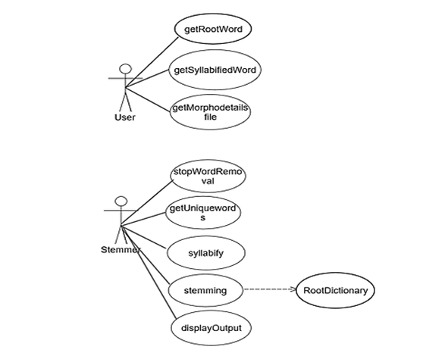Fig: 4.1.1 Use case diagram

**4.2 CLASS DIAGRAM:**

**Class diagram**: The UML class diagram is also known as object modeling. It is static diagram. These diagram shows the static structure of the model. A class diagram is a connection of static model elements, such as classes and relationships ,connected as a graph to each other and to their contents.

**Diagram Elements**:

* Each class is represented by a rectangle subdivided into three components Name, Attribute, Operations.
* There are different relationships between classes. They are association ,generalization, dependency, etc

The class diagram for our project is as follows:

It consists of 6 classes namely User, Stemmer, StopWordRemoval, Syllabification, Stemming, UniqueWords.

Each class has an association relationship between them and has attributes and methods.

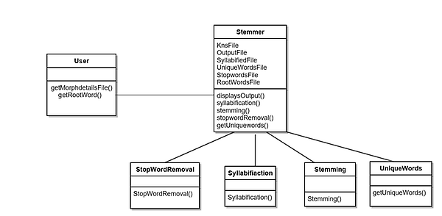

Fig: 4.2.1 Class diagram

**4.3 SEQUENCE DIAGRAM:**

Sequence is what happens next. Sequence diagrams are closely related to collaboration diagram. The sequence diagram A sequence diagram is a graphical view of scenario that shows object interactions in a time based system.

A sequence diagram shows, as parallel vertical lines (lifelines), different processes or objects that live simultaneously, and, as horizontal arrows, the messages exchanged between them, in the order in which they occur. This allows the specification of simple runtime scenarios in a graphical manner.

The sequence diagram for our project is as follows:

It consists of different objects namely, Client ,System ,Server, Stemmer, FileUpload, Syllabification.

Different messages are passed between these objects to achieve the functionality of the system.

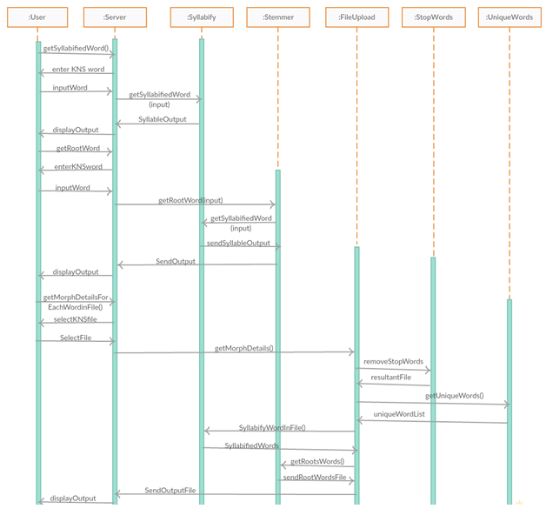

Fig: 4.3.1 Sequence Diagram

**4.4 COLLABORATION DIAGRAM:**

A collaboration diagram, also called a communication diagram or interaction diagram, is an illustration of the relationships and interactions among software objects in the Unified Modeling Language (UML). A collaboration diagram resembles a flow chart that portrays the roles, functionality and behavior of individual objects as well as the overall operation of the system in real time. Objects are shown as rectangles with naming labels inside. These labels are preceded by colons and may be underlined. The relationships between the objects are shown as lines connecting the rectangles. The message between objects are shown as arrows connecting the relevant rectangles along with labels that define the message sequencing.

The collaboration diagram for our project is as follows:

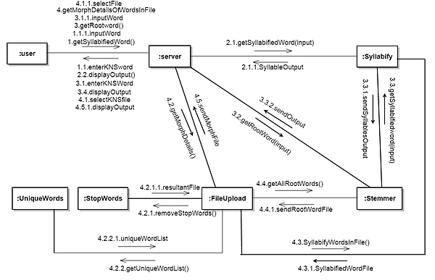

Fig: 4.4.1 Collaboration Diagram

**4.5 DEPLOYMENT DIAGRAMS:**

Deployment diagrams are used to visualize the topology of the physical components of a system where the software components are deployed. So deployment diagrams are used to describe the static deployment view of a system. Deployment diagrams consist of nodes and their relationships. The name *Deployment* itself describes the purpose of the diagram. Deployment diagrams are used for describing the hardware components where software components are deployed. Component diagrams and deployment diagrams are closely related.

The Deployment diagram for our project is as follows:

Clients: Those who interact with our system.

Web Server: For taking input and redirecting.

Application Server: For running the scripts.

Database: It consists of the files we have used for our project.

Database

Application

Server

Web Server

Client 1

Client 3

Client 2

Fig: 4.5.1 Deployment Diagram

5. RESULTS

**5.1 THE HOME PAGE:**

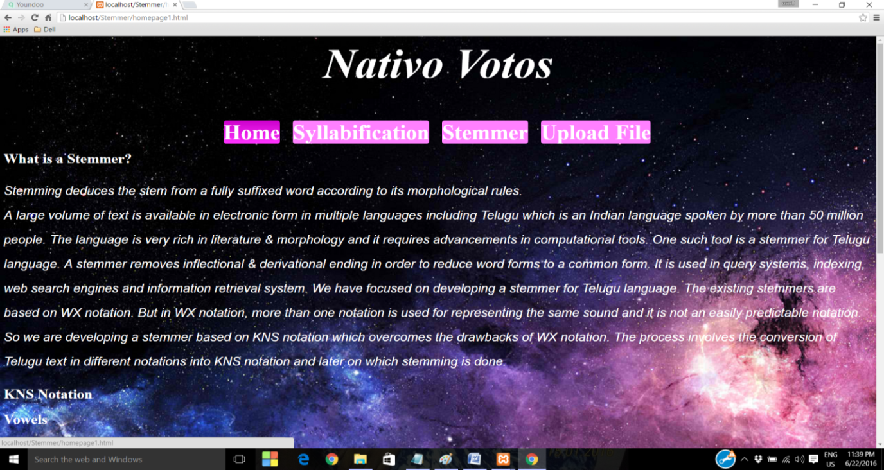

Fig: 5.1.1 Introduction

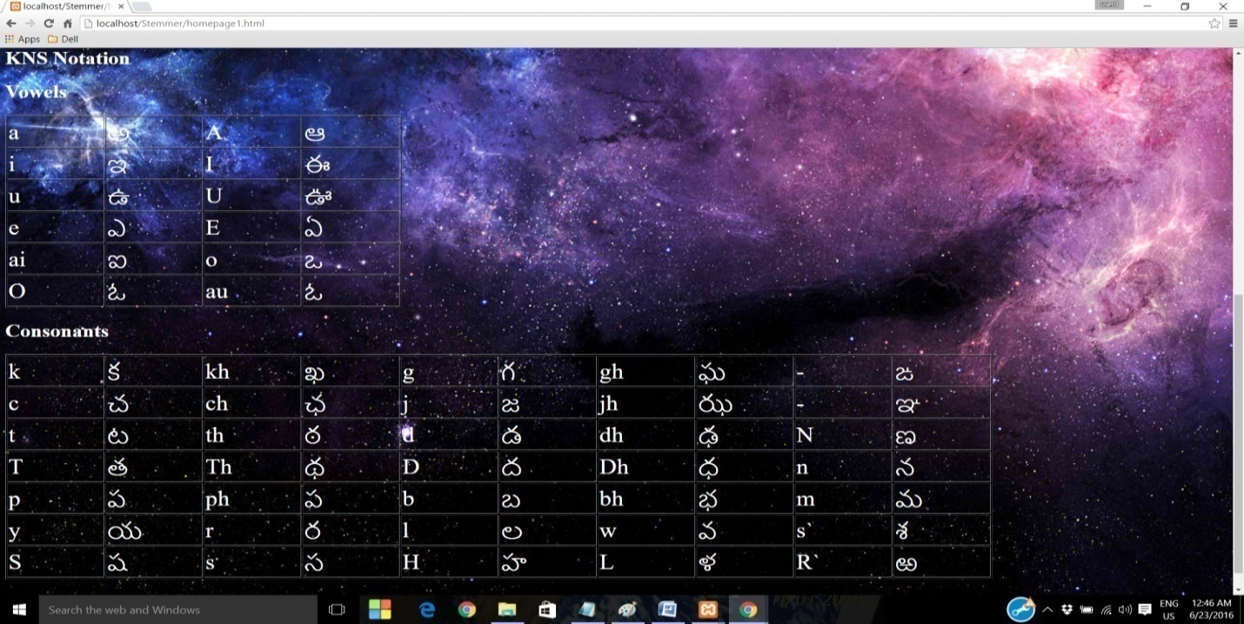

Fig: 5.1.2 KNS Notation

**5.2 SYLLABIFICATION**:

1) 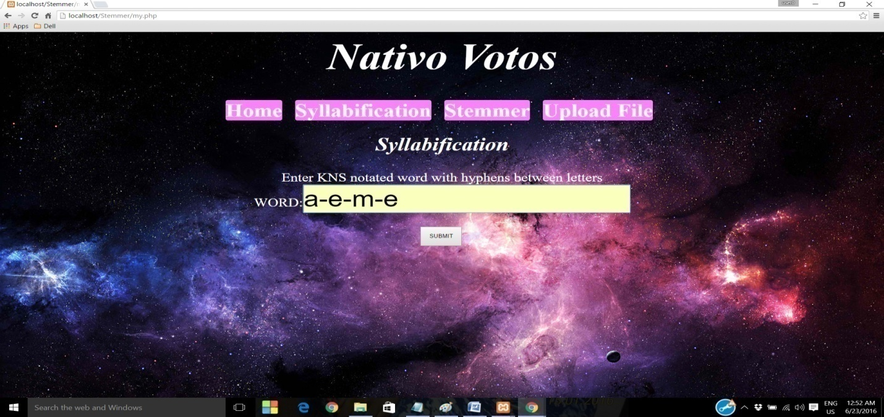 Fig 5.2.1 Input 1: a-e-m-e

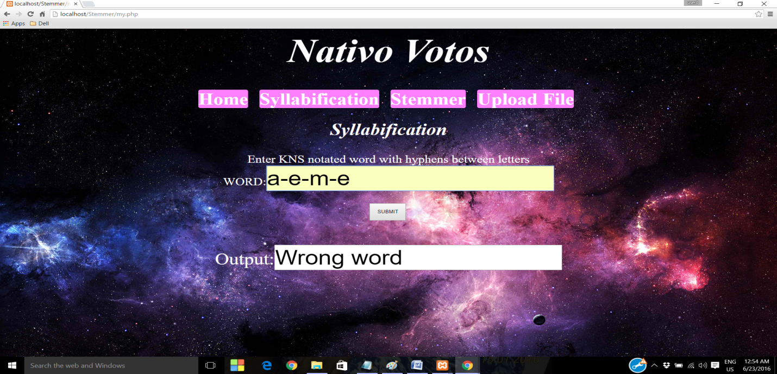

Fig:5.2.2 Output 1: Wrong word

2)

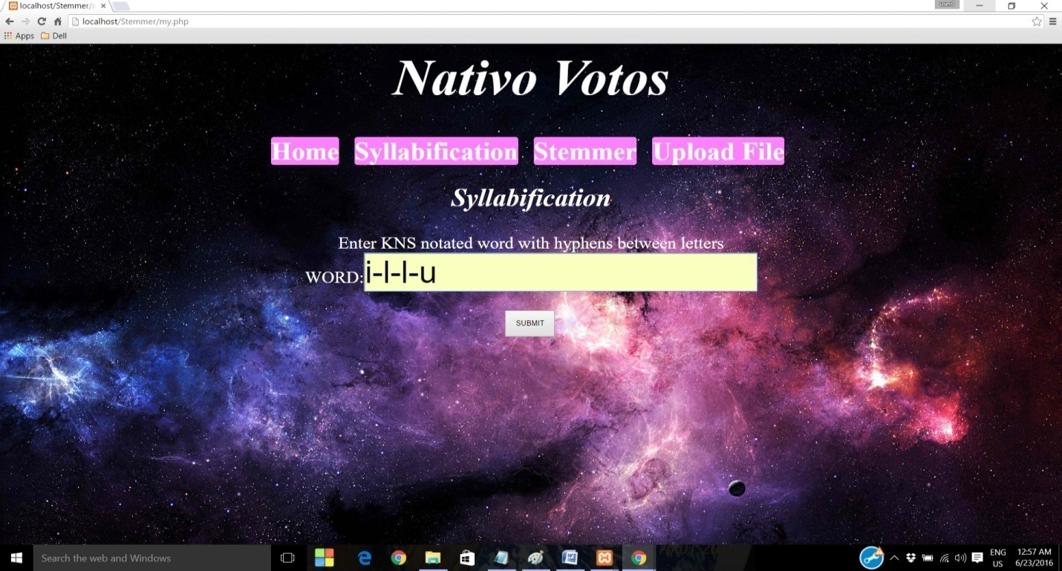

Fig:5.2.3 Input 2: i-l-l-u

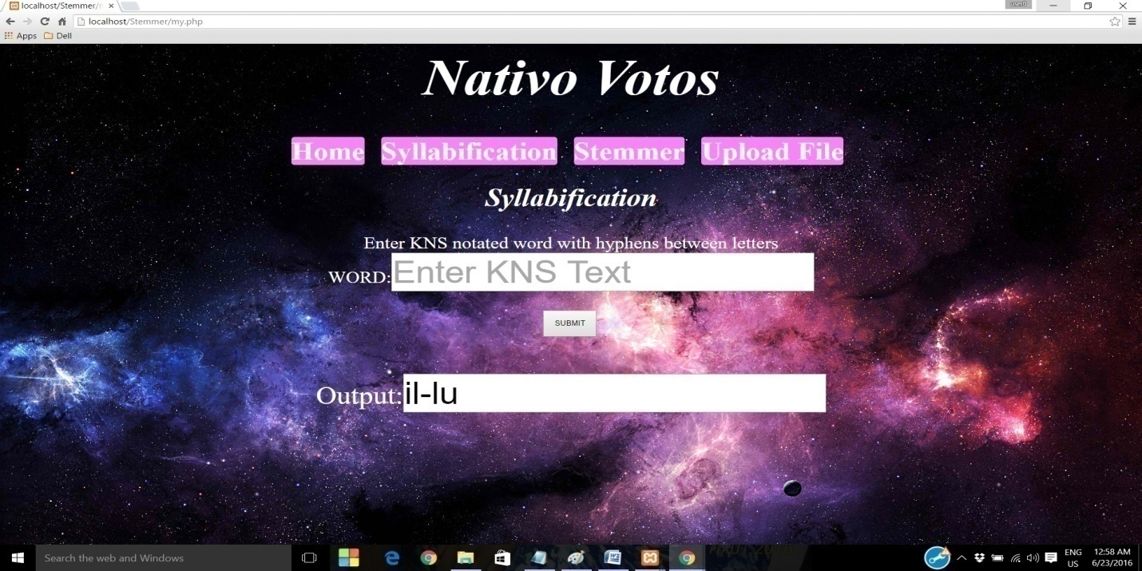Fig:5.2.4 Output 2: il-lu

3) 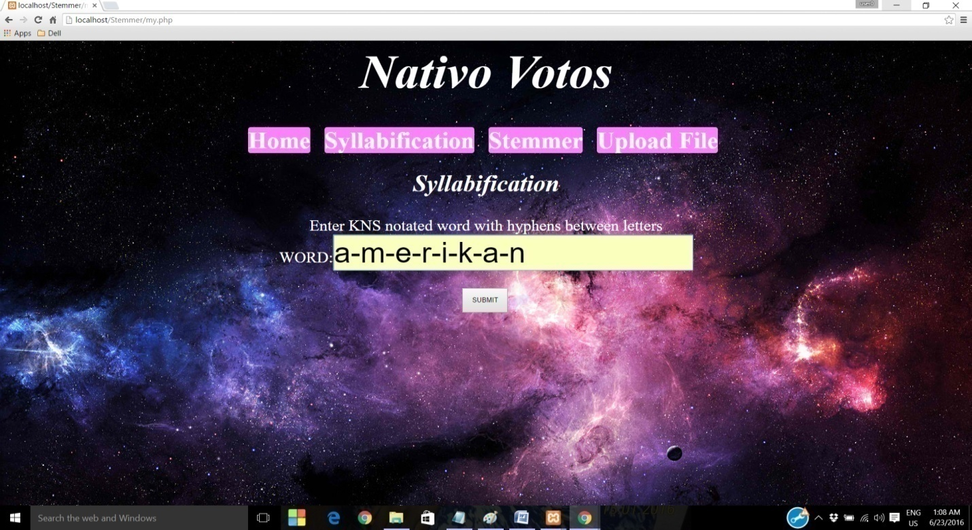

Fig:5.2.5 Input 3:a-m-e-r-i-k-a-n

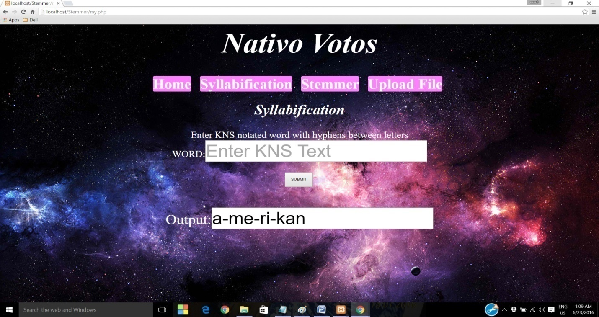

Fig:5.2.6 Output 3:a-me-ri-kan

**5.3 STEMMING:**

1)Plural la->lu

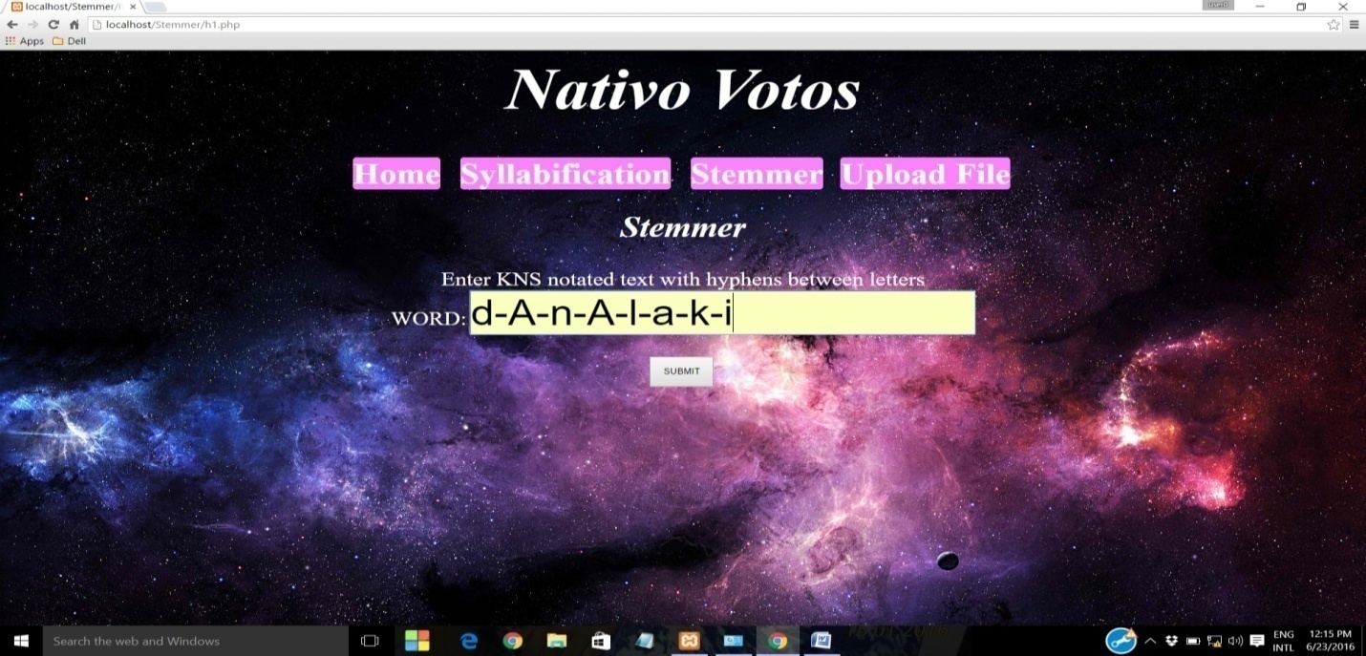

Fig:5.3.1 Input 1: dAnAlaki

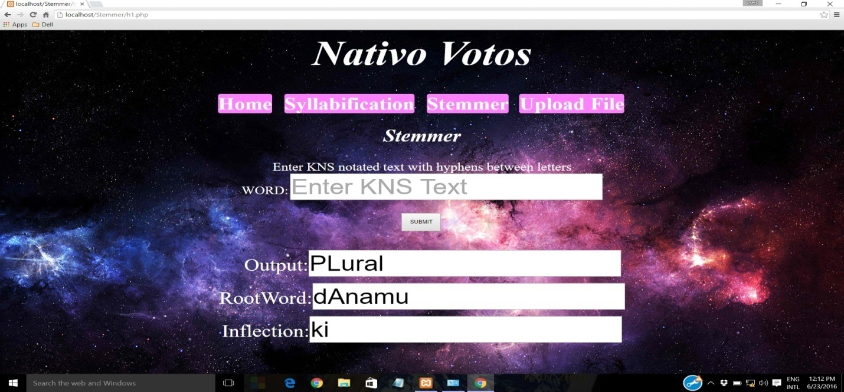

Fig:5.3.2 Output 1:dAnamu

2)

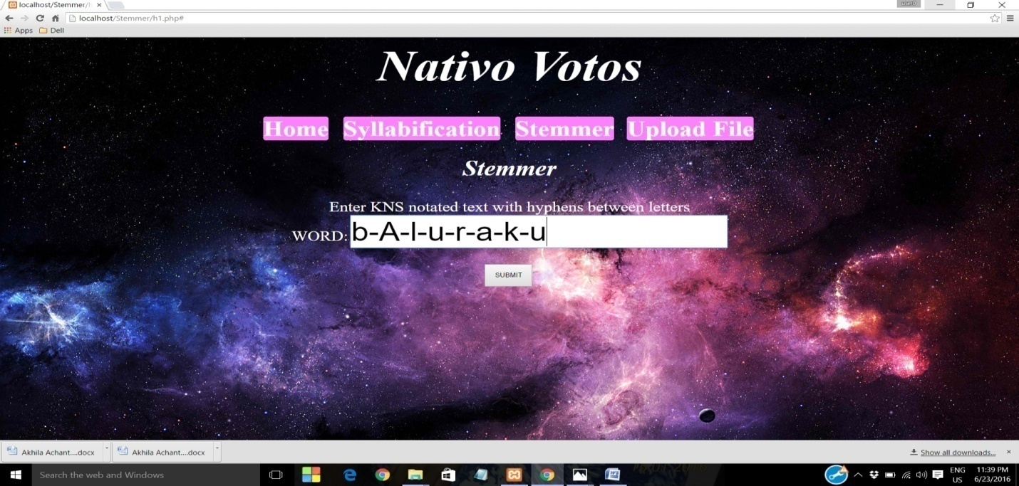

Fig :5.3.3 Input 2: bAluraku

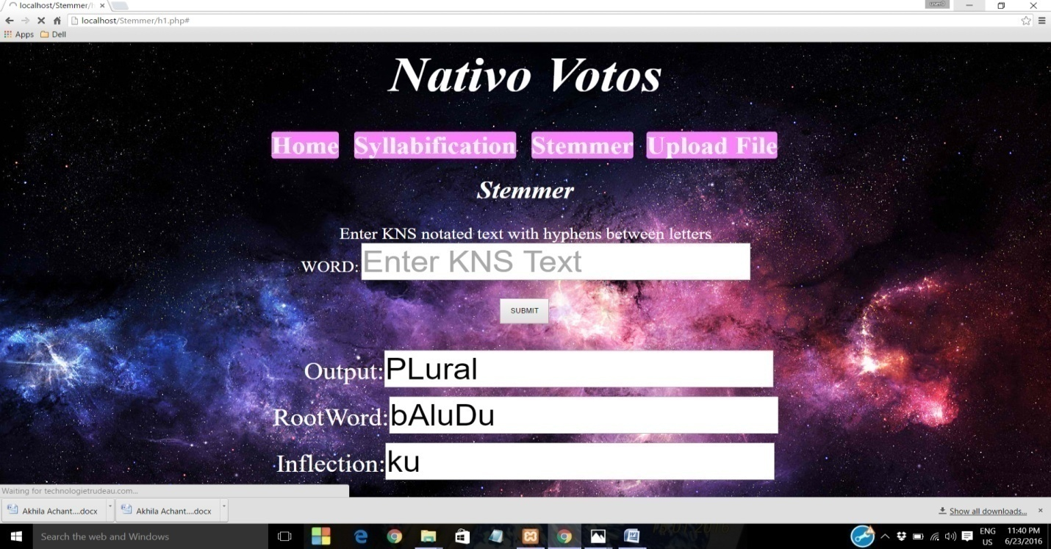

Fig:5.3.4 Output 2: bAludu

3)

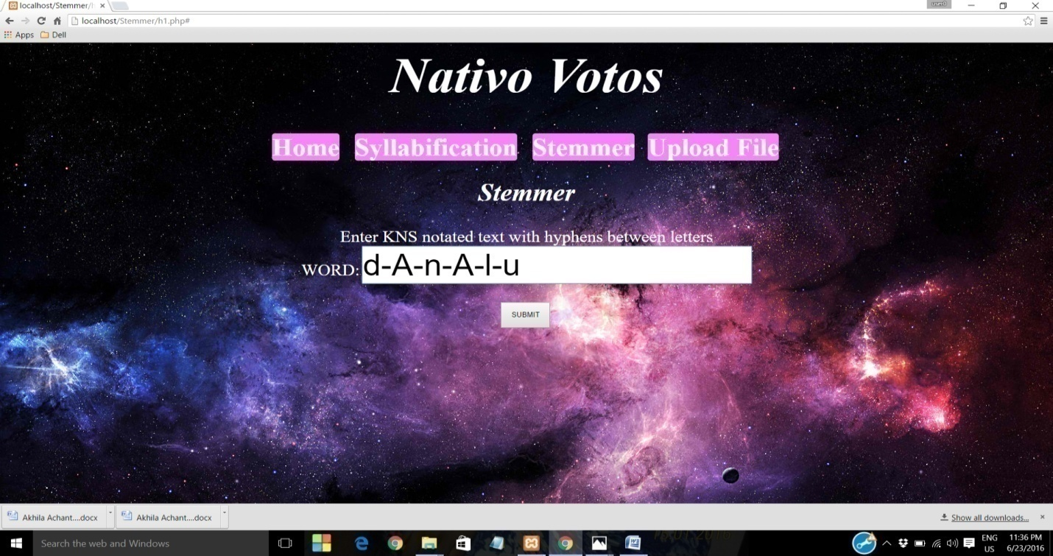

Fig: 5.3.5 Input 3: dAnAlu

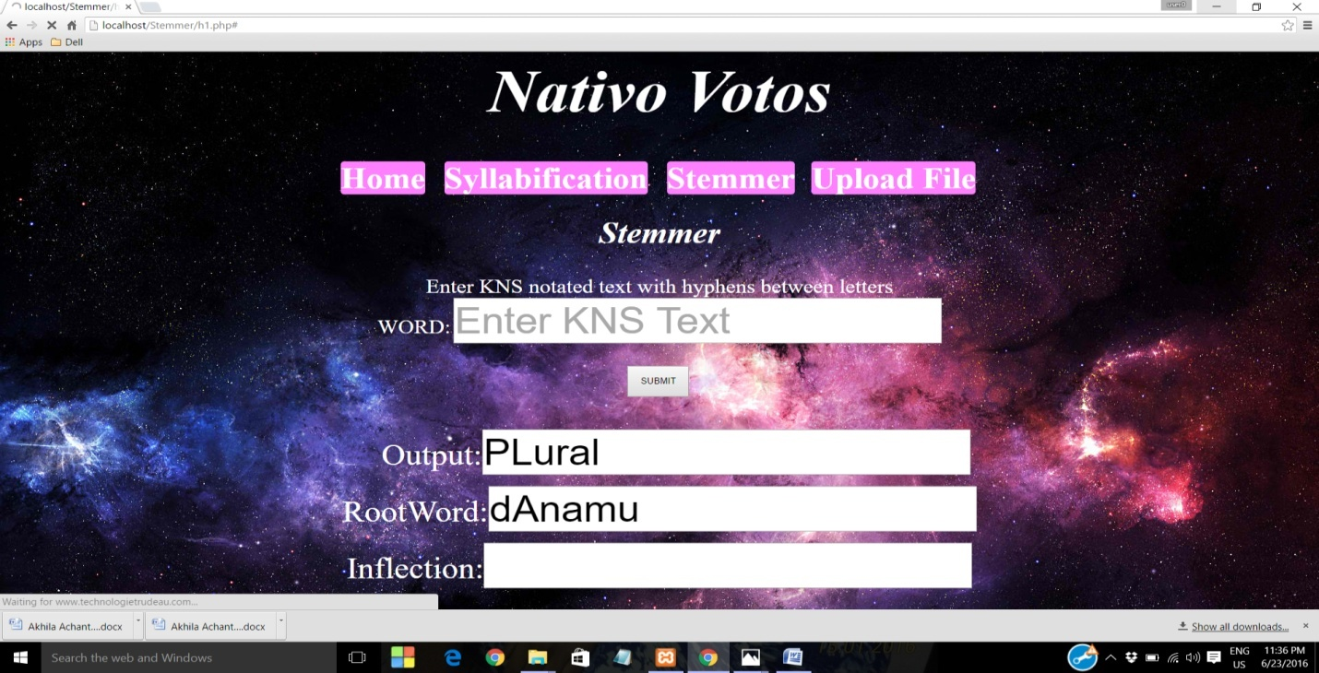

Fig:5.3.6 Output 3: dAnamu

4)

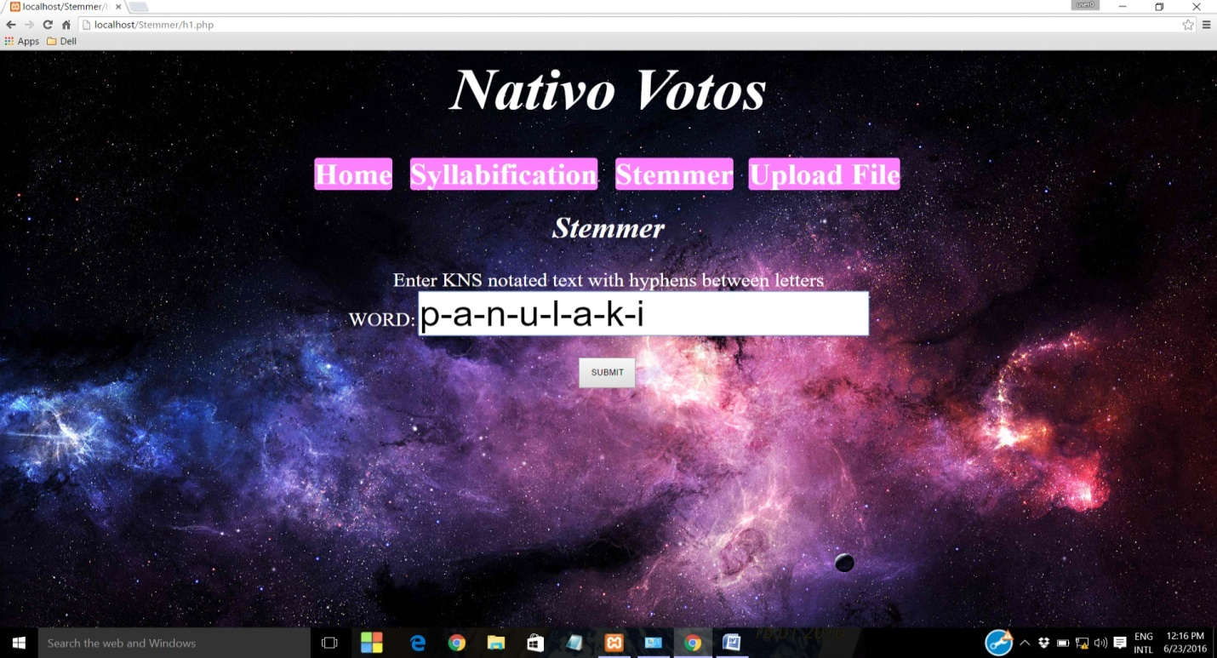

Fig:5.3.7 Input 4:panulaki

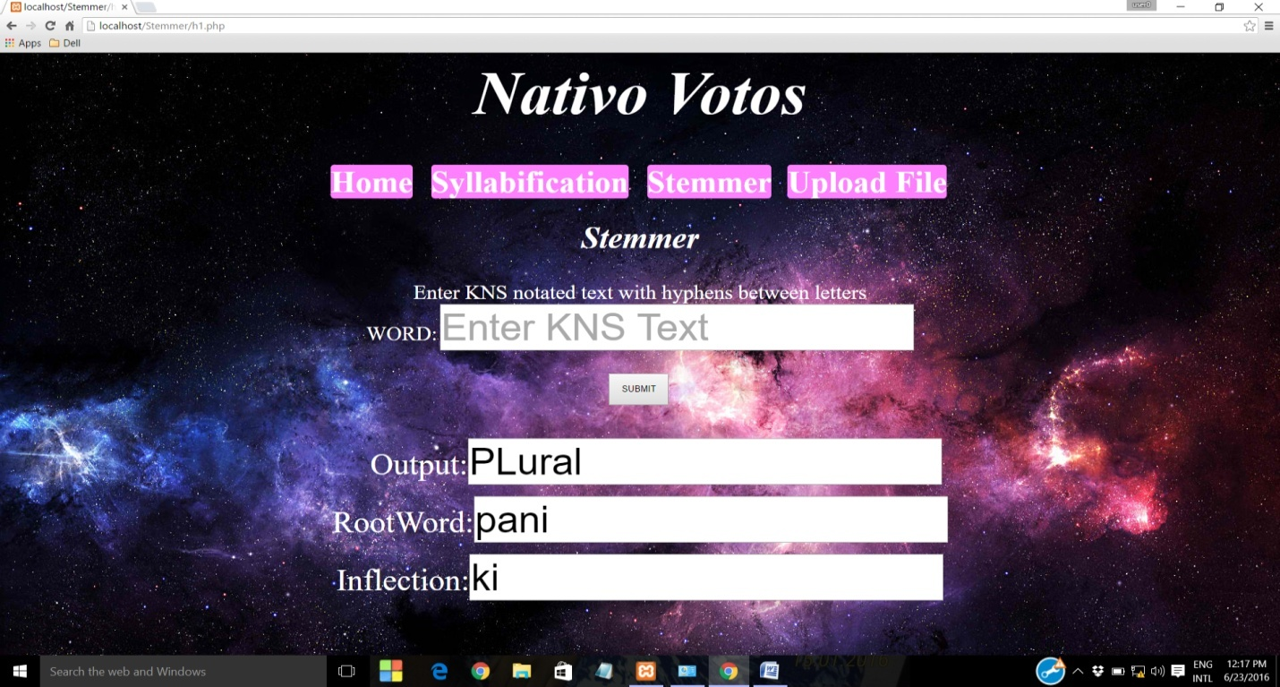

Fig:5.3.8 Output 4:pani

5)

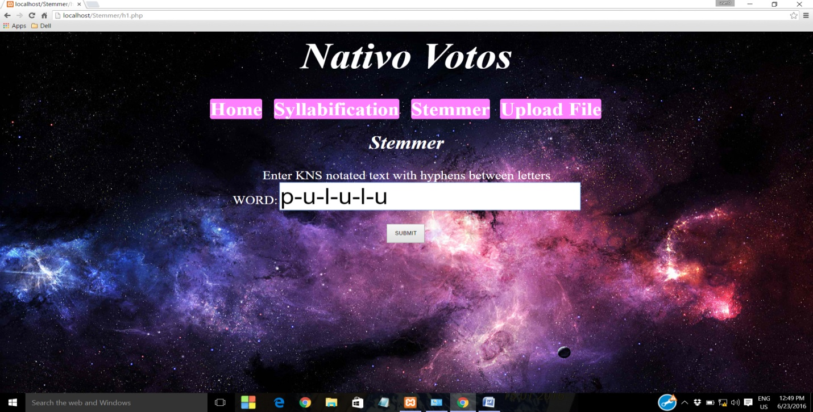

Fig:5.3.9 Input 5:pululu

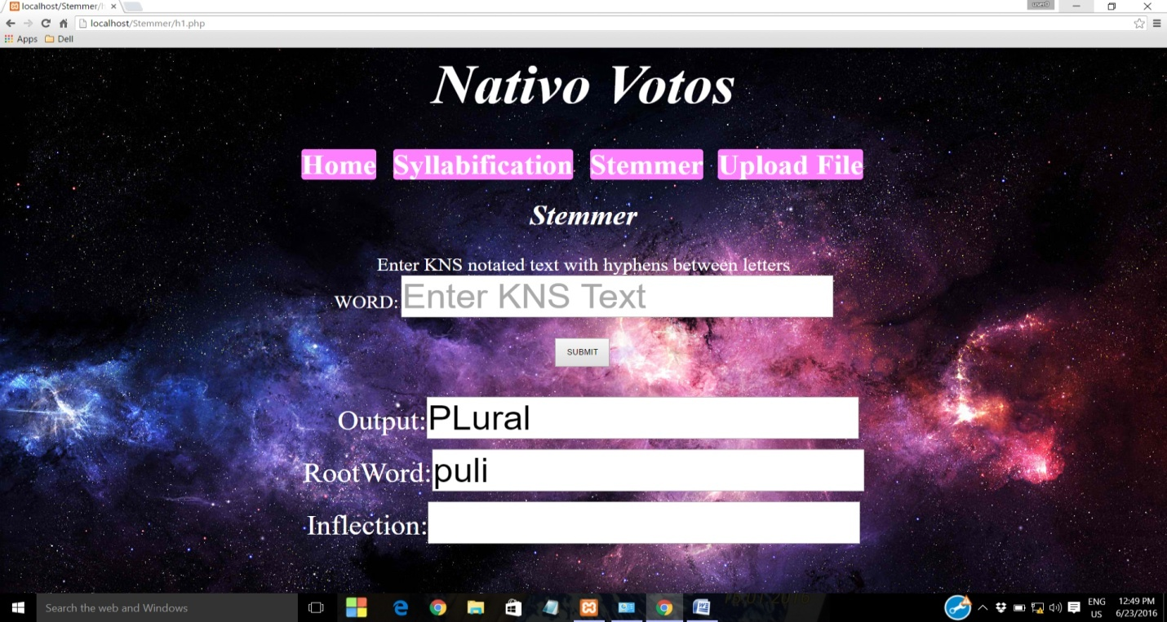

Fig:5.3.10 Output 5:puli

6)

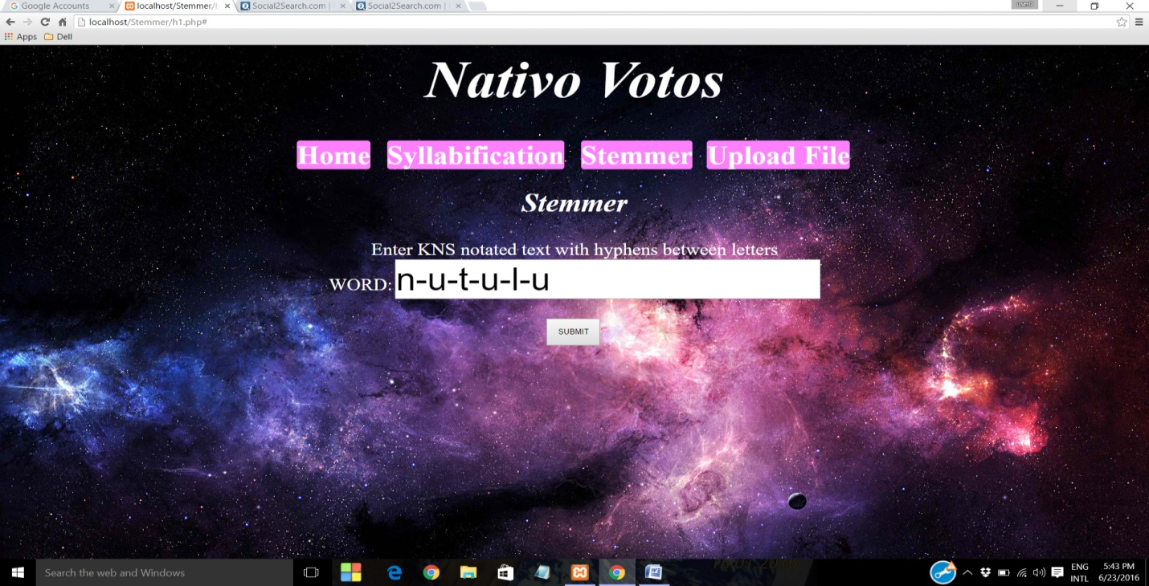

Fig:5.3.11 Input 6: nutulu

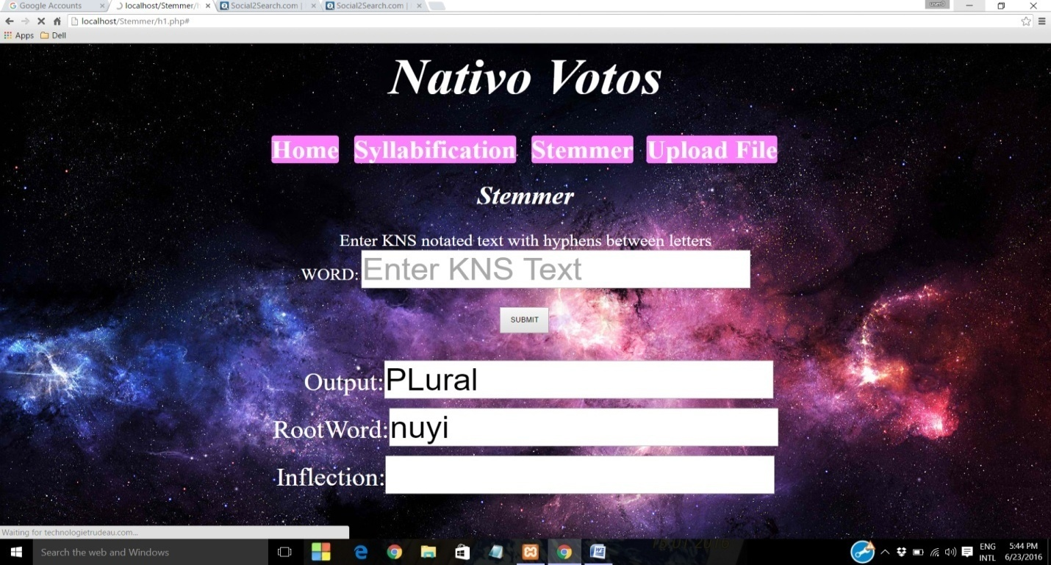

Fig:5.3.12 Output 6: nuyi

**7)**

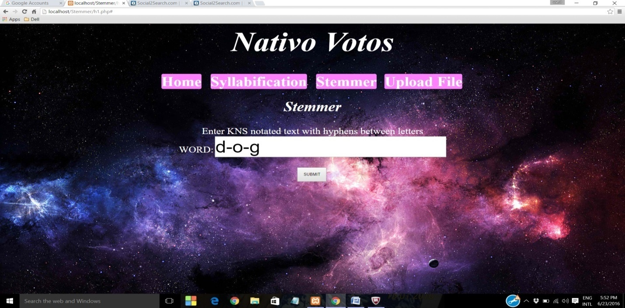

Fig:5.3.13 Input 7:dog

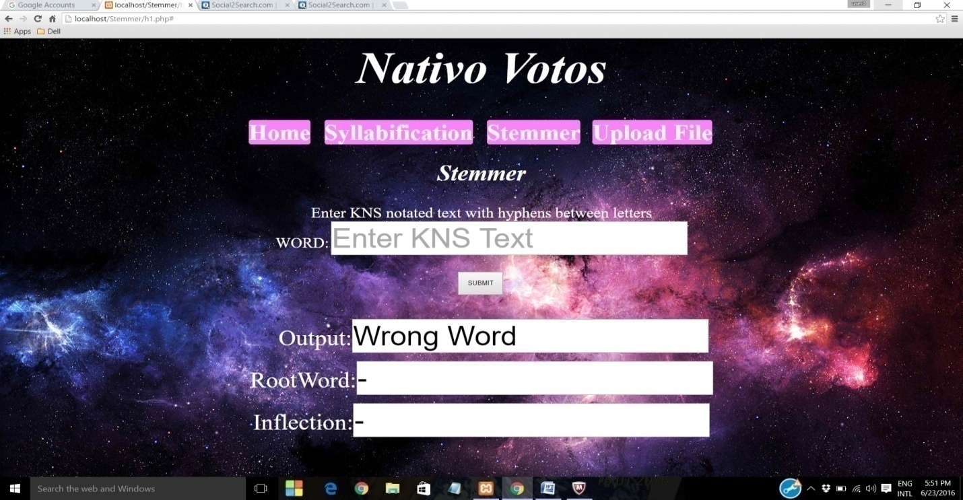

Fig:5.3.14 Output 7: Wrong Word

**5.4 UPLOAD FILE INPUTS:**

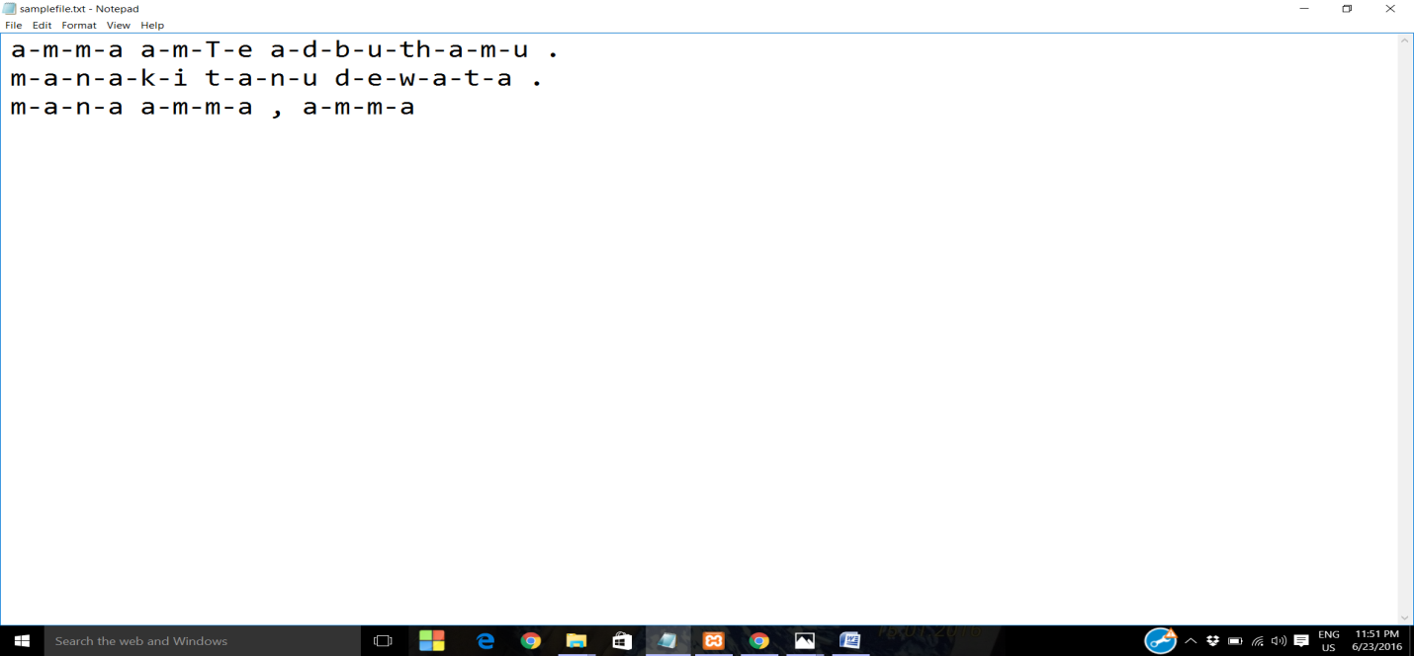

Fig:5.4.1 The input file is: samplefile.txt

**OUTPUT:**

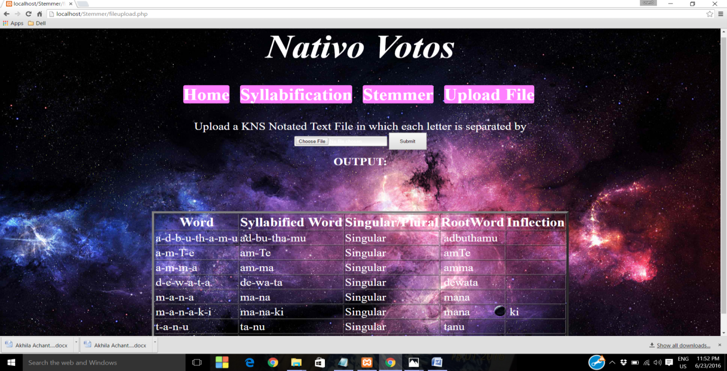

Fig:5.4.2 Output of given file

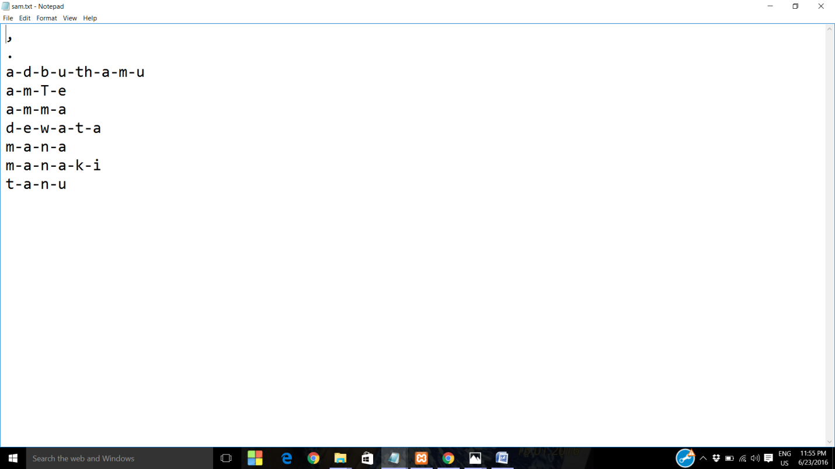

Fig: 5.4.3 Internally generated file after extracting unique words

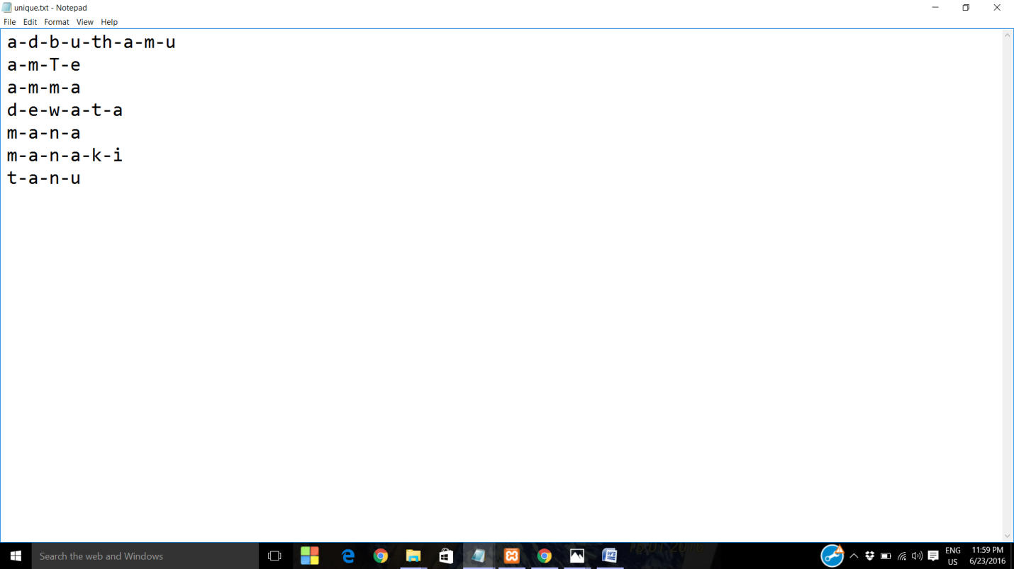

Fig: 5.4.4 File after removing stop words

**6. CONCLUSION:**

The aim of this project is to build an effective stemmer for Telugu language using a notation which is more efficient and is easily recognizable. This project uses KNS notation which eliminated the disadvantages of WX notation which is being used in existing Telugu Stemmers and verified the working of our Stemmer on 1500 words with good accurate results. This project employs inflectional Stemming by considering various rules in each step of the process. These rules are formed based on the nature of Telugu language. We are happy to work on this project which gave us immense satisfaction and vast knowledge

**6.1 FUTURE ENHANCEMENTS:**

With this working stemmer, the next step that could be put forth is the design of Morphological Analyzer which recognizes whether a word is a noun, a verb or an adjective. The basis for a Morphological analyzer is a Stemmer. We can go for further advancements like Speech Recognition, Information Retrieval, etc.

REFERENCES

[1] Dr.K.V.N Sunitha and Ms.A.Sharada- Telugu Phoneme set and its phonetic transcription using KNS notation-Journal paper.

[2] KVN Sunitha, N.Kalyani-Unsupervised Stemmer to Improve Rule Based Morph Analyzer-IEEE paper.

[3] T. Kameswara Rao, T.Ashok Kumar, T. V. Prasad- Handling plural forms of Telugu Words in Machine Translation-IEEE paper

[4] Telstem :an unsupervised Telugu Stemmer with heuristic improvements.

[5] A Telugu Morphological Analyzer- Uma Maheshwar Rao G., Amba Kulkarni P. and Christopher Mala Center for Applied Linguistics and Translation Studies University of Hyderabad.

[6] TelMore: Morphological Generator for Telugu Nouns and Verbs -Madhavi Ganapathiraju and Lori Levin Language Technologies Institute, Carnegie Mellon University, Pittsburgh, PA 15213, USA.

[7] Mayareport.pdf

[8] Key Issues in Vowel Based Splitting of Telugu Bigrams- T.Kameswara Raa,T.V.Prasad,

International Journal of Advanced Computer Science and Applications, Special Issue on Natural Language Processing 2014.

[9] LTRC (Language Technologies Research Center,IIIT-Hyderabad) -https://ltrc.iiit.ac.in/.

[10] www.tutorialspoint.com/perl.

[11] www.perlmaven.com